ISOLATED SYSTEMS FOR BESS

In Accordance with IEC / BE EN 62305-2024

Lightning protection is a controlled engineering process defined by the IEC 62305 standard series.
A fundamental step of this process is the risk assessment, which determines the required level of lightning and surge protection based on factors such as geographical location, surrounding environment, structure geometry, and the functional importance of the protected installation.
For Battery Energy Storage System (BESS) installations, lightning protection design requires particular attention due to:
- the presence of lithium-ion batteries and power electronics,
- high sensitivity of BMS, PCS, and communication systems to electromagnetic disturbances and overvoltages,
- compact metallic container construction with limited achievable separation distance,
- frequent use of multi-unit layouts interconnected with MV skid equipment,
- and, in many projects, installation on rocky or uneven terrain where effective earthing is difficult to implement.
In conventional lightning protection concepts, air-termination rods and conductors mounted directly on container structures may allow partial lightning current flow, electromagnetic coupling, and unpredictable potential distribution within interconnected BESS systems.
These effects become more significant as the number of interconnected units increases and where terrain conditions limit the performance of standard Type B earthing arrangements required by IEC 62305-3.
The HVI insulated lightning protection system addresses these limitations by providing:
- a controlled and insulated lightning current path separated from the protected structure,
- reduced electromagnetic interaction with internal electrical systems,
- improved predictability of Lightning Protection Zones (LPZ) across multi-container configurations,
- and simplified installation directly on BESS or MV skid structures, eliminating dependence on ground-mounted masts in difficult terrain.
For these reasons, HVI technology represents a more robust and reliable engineering solution for modern BESS installations, particularly in multi-unit systems and geologically challenging sites, and is therefore considered in this document as the primary reference protection concept in accordance with IEC 62305.
Contents
1. Executive Summary 4
2. Purpose of the Document 4
3. Applicable Standards 5
4. BESS-Specific Lightning Protection Challenges 5
4.1 Lithium-ion fire hazard 5
4.2 High-density power electronics 5
4.3 Compact metallic enclosures 5
5. Risk Assessment Requirement 6
6. Protection Concepts Considered 6
6.1 HVI Insulated Lightning Protection System 6
Contribution of Insulated Lightning Protection (HVI) to High BESS Availability 7
7. Single BESS Unit Protection Concept 8
7.1 Geometry Assumption 8
7.2 Pricing Summary – Single BESS 8
8. MV Skid Protection Concept (5 MW Class) 10
8.1 Equipment Scope 10
8.2 Pricing Summary – MV Skid 10
9. Site-Level Lightning Protection Strategy 12
10. Earthing and Surge Protection Coordination 14
10.1 Earthing system 14
10.2 Surge protection devices (SPD) 15
11. Fire Safety Considerations 15
12. Installation and Constructability 16
12.1 HVI 16
12.2 Masts 16
13. Comparative Technical Evaluation 16
14. Recommended Application Areas 17
15. Scope Limitations 17
16. Conclusion 17
17. Next Engineering Steps 18

TECHNICAL DESIGN CONCEPT
Lightning Protection System for BESS Installations In accordance with IEC 62305

1. Executive Summary
This document presents a conceptual technical design for lightning protection of Battery Energy Storage System (BESS) installations in compliance with IEC 62305.
Fully compliant protection approaches are evaluated:
- HVI insulated lightning protection system
- Earth System
The study covers:
- single BESS container units
- MV skid units (5 MW class)
- optimized site-level configurations
The HVI provides the highest safety level in terms of:
- separation distance control
- fire and explosion risk reduction
- electromagnetic compatibility
- predictable LPZ zoning
Final selection shall be confirmed by risk assessment according to IEC 62305-2.

2. Purpose of the Document
The purpose of this document is to:
- define lightning protection concepts for BESS infrastructure
- compare compliant protection technologies
- provide preliminary bills of materials and pricing
- support early-stage engineering and budgeting
This document does not constitute a detailed design.

3. Applicable Standards
The design concept is based on:
- IEC 62305-1 – General principles
- IEC 62305-2 – Risk management
- IEC 62305-3 – Physical damage to structures and life hazard
- IEC 62305-4 – Electrical and electronic systems within structures
Additional coordination required with:
- earthing system design
- surge protection device (SPD) concept
- fire safety engineering

4. BESS-Specific Lightning Protection Challenges
BESS installations introduce unique risks:

4.1 Lithium-ion fire hazard
Direct or partial lightning current may initiate:
- thermal runaway
- enclosure ignition
- cascading battery failure

4.2 High-density power electronics
Sensitive components include:
- BMS
- PCS
- communication and SCADA systems
These are highly vulnerable to:
- induced overvoltages
- electromagnetic fields
- ground potential rise

4.3 Compact metallic enclosures
Containerized BESS geometry often makes classical separation distance impossible.

5. Risk Assessment Requirement
Exact LPS class must be determined using:
IEC 62305-2 risk assessment, considering:
- lightning ground flash density
- structure dimensions
- occupancy and fire consequences
- service continuity requirements
Until risk calculation is completed, this document presents:
engineering-based preliminary scenarios.

6. Protection Concepts Considered

6.1 HVI Insulated Lightning Protection System
Principle
Controlled conduction of lightning current through an insulated high-voltage conductor maintaining separation distance from:
- metallic container walls
- internal installations
- cable routes
The HVI system will require trained personnel to install and maintain it in accordance with the manufacturer’s standards.
Key Advantages
Fire safety
No partial current through battery enclosure.
Explosion risk reduction
Current routed outside hazardous zone.
Electromagnetic protection
Reduced coupling into BMS/PCS.
IEC compliance in compact layouts
Maintains separation where classical rods cannot.
Predictable LPZ zoning
Critical for utility-scale BESS.

Contribution of Insulated Lightning Protection (HVI) to High BESS Availability
Achieving a target operational availability of approximately 97% in Battery Energy Storage System (BESS) installations depends on multiple coordinated protection measures, including lightning protection, earthing, surge protection, system architecture, and redundancy.
The selection of an insulated lightning protection system such as HVI significantly contributes to maintaining operational continuity.
By ensuring a controlled lightning current path and maintaining the required separation distance from conductive structures and internal electrical systems, HVI minimizes the probability of:
- partial lightning current flowing through container structures, bonding networks, or cable shields,
- excessive electromagnetic coupling into BMS, PCS, and communication circuits,
- surge-induced trips, resets, or temporary system outages.
In compact, multi-unit BESS configurations where classical separation distance is difficult or impractical to achieve, insulated lightning protection provides a more predictable and verifiable compliance with IEC 62305, thereby reducing the likelihood of lightning-related disturbances that could impact system uptime.
For this reason, insulated lightning protection solutions are commonly adopted in high-availability and utility-scale BESS projects as a key supporting measure for achieving the required operational availability targets.

7. Single BESS Unit Protection Concept

7.1 Geometry Assumption
Typical container:
6.1 m × 3 m × 2.9m
The compliant solutions evaluated:
- HVI insulated air-termination

7.2 Pricing Summary – Single BESS

The Price is dependent on exact mounting position on a BESS unit. Below you will find examples and Price Comparison for different method of protection [euro]
 | I | II | III | IV | Wind Load
HVI Light Plus | 1 583,76 | 858,83 | 429,41 |  | 228 km/h
HVI Long | 1 842,1 | 617,52 | 617,52 |  | 173 km/h

Level I LPS examples - HVI Light Plus.
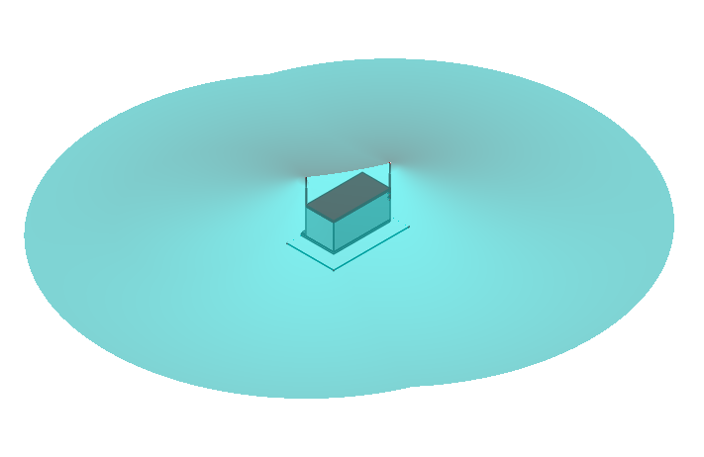
Level II LPS examples - HVI Long.
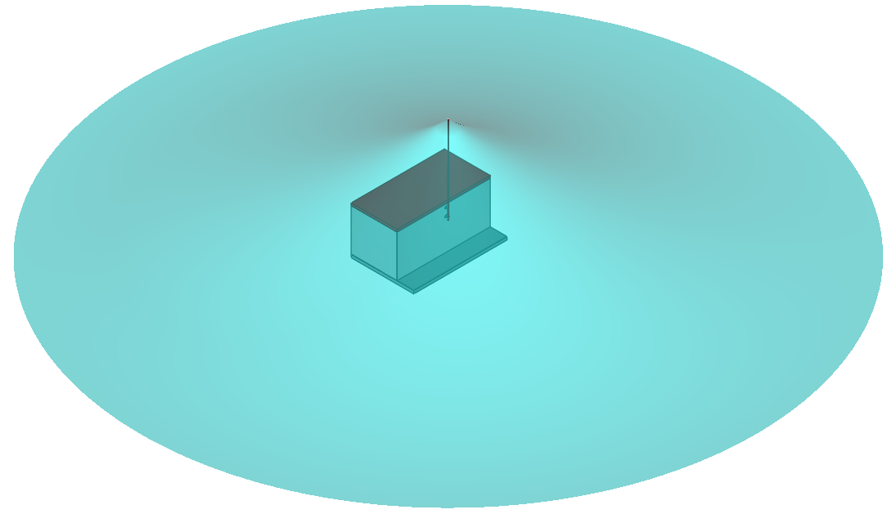

Level III/IV LPS examples - HVI Light Plus.
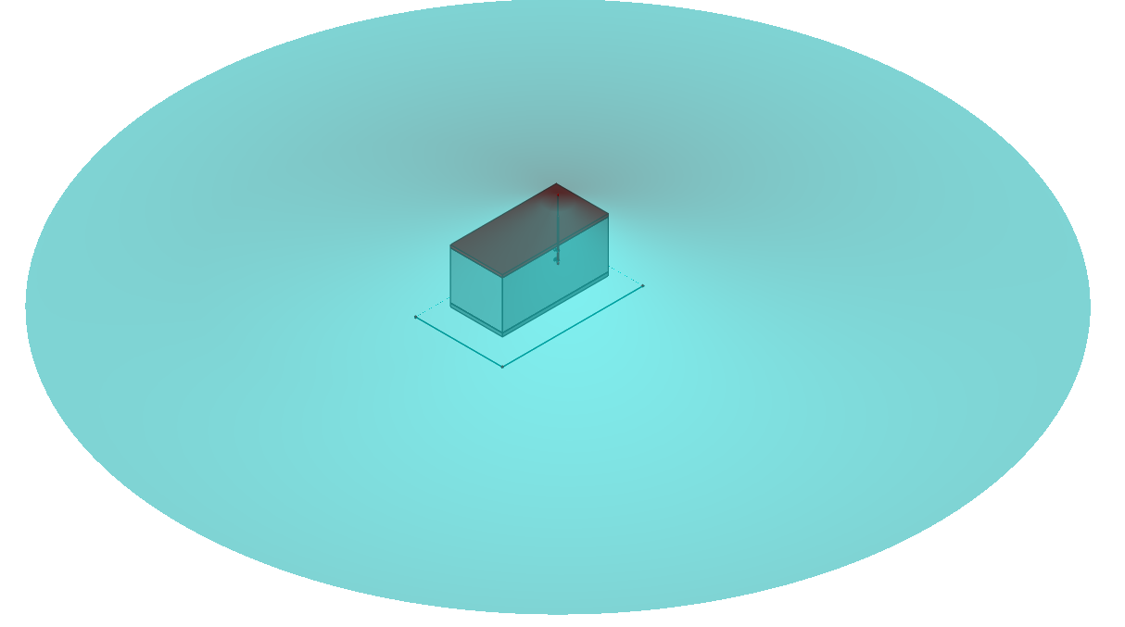

8. MV Skid Protection Concept (5 MW Class)

8.1 Equipment Scope
- 4× PCS
- transformer
- MV switchgear
- 40HC container equivalent

8.2 Pricing Summary – MV Skid
The Price is dependent on exact mounting position on a MV Skid unit. Below you will find examples and Price Comparison for different method of protection [euro]
 | I | II | III | IV | Wind Load
HVI Light Plus | 3 167,52 | 858,83 | 858,83 |  | 228 km/h
HVI Long | 3 684,20 | 1 235,04 | 617,52 |  | 173 km/h

Level I LPS examples - HVI Long.
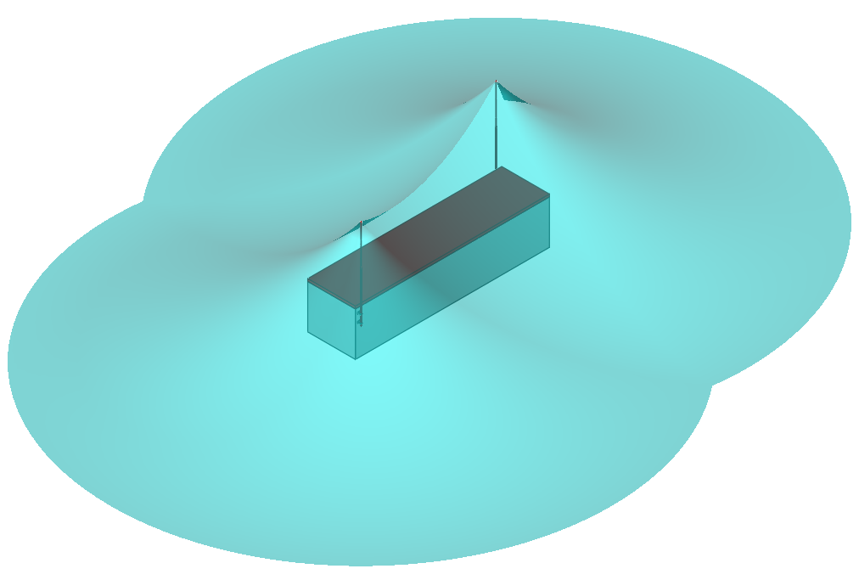

Level II LPS examples - HVI Light Plus.
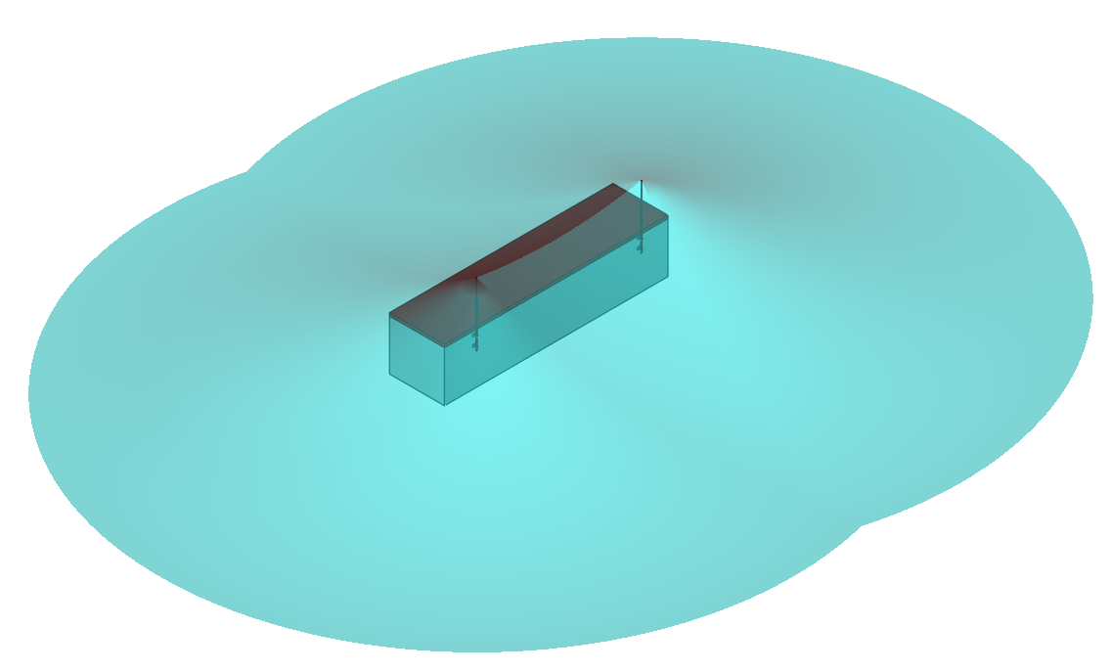

Level III/IV LPS examples - HVI Long.
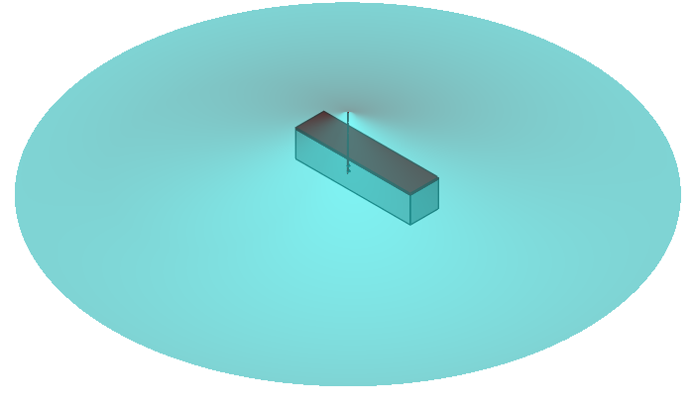

9. Site-Level Lightning Protection Strategy
When full layout is available, optimization includes:
- coordinated air-termination positioning
- shared interception zones
- minimized conductor routing
- integrated LPZ zoning
- coordination with earthing grid

Site Option
If the overall site layout and configuration are known, the lightning protection system can be optimized accordingly. Examples of such optimization are presented below.

Example ‘A’
HVI Solution – LPS Level II
Three HVI Light Plus Masts and One HVI Long with single down conductors.

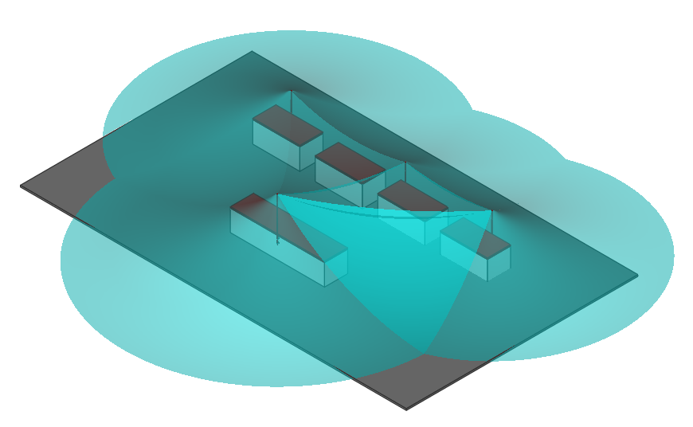

Additional Tools and Miscellaneous
The Signs must be ordered to match number of the HVI masts on site.
480598 | TBC | ea | Instruction plate "ATTENTION! Separated Lightning Protection with HVI conductor system"
480699 | TBC | ea | Warning sign 297x210x0.7mm Al Bei Gewitter ist der Aufenthalt ...
597220 | TBC | ea | HVI strip 20 stripping tools for HVI Conductors -KIT-
597101 | TBC | ea | HVI head 20 spare blades for cutting head (1pack of 4 blades)
597032 | TBC | ea | HVI cutter cable shears for HVI/CUI Conductors up to D 32mm

10. Earthing and Surge Protection Coordination
A complete BESS lightning protection design must include:

10.1 Earthing system
- low-impedance grounding network
- equipotential bonding of containers
- lightning current dispersion capability
The Earth arrangement with British Standard parts, the earth arrangement must have low level bond to the Container spaced every 5m. The Earthing Studies and Soli resistivity test are essential to determine exact earthing arrangement.

Single MV Skid & BESS Combine Type A and B For Two Air Termination Rod
Total Price: | €793.59
PIT3 | 2 | ea | Plastic pit (Pt No. 138092)
PIT6 | 2 | ea | Earth Bar for use in PIT3 (Pt No. 138096)
TPGY253 | 25 | m | 25 x 3 Copper tape Grey (Pt No. 128034)
DCPGY | 100 | ea | NM clip Grey for PVC (Pt No. 118023)
BBC | 16 | ea | Copper tape B bond (Pt No. 118270)
TC2530 | 50 | m | 25 x 3 Bare Copper tape (Pt No. 128010)
STC253 | 5 | ea | 25 x 3 Gunmetal square tape clamp (Pt No. 118200)
RTA1 | 2 | ea | Rod to tape clamp (Pt No. 610025)
DBS1612 | 6 | ea | Copper bond earth rod 16x1200 to BS (Pt No. 614120)
DCP16H | 4 | ea | 16mm hexagonal coupling (Pt No. 610158)

Single MV Skid and BESS Combine Type A and B For Single Air Termination Rod
Total Price: | €737.60
PIT3 | 1 | ea | Plastic pit (Pt No. 138092)
PIT6 | 1 | ea | Earth Bar for use in PIT3 (Pt No. 138096)
TPGY253 | 25 | m | 25 x 3 Copper tape Grey (Pt No. 128034)
DCPGY | 100 | ea | NM clip Grey for PVC (Pt No. 118023)
BBC | 8 | ea | Copper tape B bond (Pt No. 118270)
TC2530 | 50 | m | 25 x 3 Bare Copper tape (Pt No. 128010)
STC253 | 5 | ea | 25 x 3 Gunmetal square tape clamp (Pt No. 118200)
RTA1 | 1 | ea | Rod to tape clamp (Pt No. 610025)
DBS1612 | 3 | ea | Copper bond earth rod 16x1200 to BS (Pt No. 614120)
DCP16H | 2 | ea | 16mm hexagonal coupling (Pt No. 610158)

Earth Example ‘A’ for Level II system
Total Price: | €1344.45
PIT3 | 4 | ea | Plastic pit (Pt No. 138092)
PIT6 | 4 | ea | Earth Bar for use in PIT3 (Pt No. 138096)
TPGY253 | 25 | m | 25 x 3 Copper tape Grey (Pt No. 128034)
DCPGY | 100 | ea | NM clip Grey for PVC (Pt No. 118023)
BBC | 30 | ea | Copper tape B bond (Pt No. 118270)
TC2530 | 100 | m | 25 x 3 Bare Copper tape (Pt No. 128010)
STC253 | 10 | ea | 25 x 3 Gunmetal square tape clamp (Pt No. 118200)
RTA1 | 4 | ea | Rod to tape clamp (Pt No. 610025)
DBS1612 | 12 | ea | Copper bond earth rod 16x1200 to BS (Pt No. 614120)
DCP16H | 8 | ea | 16mm hexagonal coupling (Pt No. 610158)

10.2 Surge protection devices (SPD)
Mandatory for:
- AC power interfaces
- DC battery circuits
- communication lines
- monitoring and control systems
Without SPD coordination, IEC 62305 compliance is incomplete.

11. Fire Safety Considerations
Lightning protection must support:
- prevention of ignition sources
- limitation of thermal effects
- avoidance of internal current paths
- compatibility with fire suppression systems
HVI provides the highest intrinsic fire safety.

12. Installation and Constructability

12.1 HVI
- requires controlled routing
- precise separation verification
- trained installation team

12.2 Masts
- minimal civil works
- rapid deployment
- easy future relocation

13. Comparative Technical Evaluation

Criterion | HVI | Conventional LPS
Fire safety | ★★★★★ | ★★★
IEC separation compliance | ★★★★★ | ★★
Installation speed | ★★★★★ | ★★★★
Layout flexibility | ★★★★★ | ★★★
Suitability for critical infrastructure | ★★★★★ | ★★
Operational continuity support | ★★★★★ | ★★
Lightning current path control | ★★★★★ | ★★

Ratings are indicative and reflect typical engineering performance in compact multi-unit BESS configurations. Final suitability depends on project-specific IEC 62305 risk assessment and detailed design.

14. Recommended Application Areas
HVI – Recommended for
- critical infrastructure BESS
- urban or compact sites
- high fire consequence scenarios
- utility-scale storage
- large open areas

15. Scope Limitations
This document:
- is conceptual only
- requires IEC 62305-2 risk assessment
- requires final engineering design
- does not replace installation design documentation
Final responsibility remains with:
installer and project engineer.
All prices and solution are subjected to specific site conditions, and they must and shall be determined before order the product.

16. Conclusion
Evaluated lightning protection concepts are fully compliant with IEC 62305 when properly designed and installed.
However, the level of risk reduction and operational predictability differs depending on the protection principle applied.
HVI insulated lightning protection provides the highest safety level for BESS installations, particularly where:
- fire risk is critical,
- achievable separation distance is limited,
- system continuity and operational availability are essential.
In contrast, conventional air-termination systems mounted directly on structures or implemented without controlled insulation may allow:
- partial lightning current flow through metallic container constructions, bonding networks, or cable shields,
- increased electromagnetic coupling into sensitive BESS power and control circuits,
- less predictable potential distribution across interconnected multi-unit systems.
While such effects do not prevent formal compliance with IEC 62305,
they may increase the probability of lightning-induced functional disturbances, system trips, or temporary outages,
which is a key consideration in BESS projects with defined operational availability targets.
For this reason, insulated lightning protection represents the most robust and predictable engineering approach
for supporting high-availability BESS operation in compact or interconnected configurations.

Final system selection shall be confirmed through:
- project-specific IEC 62305 risk assessment, and
- detailed engineering design, including earthing and surge protection coordination.

17. Next Engineering Steps
- Perform IEC 62305-2 risk calculation
- Define LPS class
- Design earthing system
- Coordinate SPD concept
- Produce detailed installation drawings
- Issue construction documentation

